Report on Mini Project
Name: Amudha. N
Batch: TN-DA-ANB11
Mail Id: sarah1986aju@gmail.com
Contact No: 9791178867
Tittle: Retail Stores Sales Dataset
Project Domain: Sales and E-Commerce
Data set year Timeline: 2022-2025 Dataset
Submission: 05-01-2025
Mentor: Kumaran. M
Raw Dataset: https://docs.google.com/spreadsheets/d/1xWpNJOIVkho3buUegv5sMr7TfPCb_D9l/edit?usp=sharing&ouid=110031930354006978938&rtpof=true&sd=true
Cleaned Dataset: https://docs.google.com/spreadsheets/d/1EPuPb8vSb4aTDzc-FrK_-rkwczFGtfkS/edit?usp=sharing&ouid=110031930354006978938&rtpof=true&sd=true
Visuals Dataset: https://drive.google.com/file/d/18SQyzA5qh6wVPUHhn9hsdTmvlutYHMOF/view?usp=sharing

Mapping Freelancer Retail Store Sales: Data Cleaning, Data Transformation, and Data Visualization
This project aims to analyze and visualize data from a global freelancer dataset to gain insights into demographics, skills, earnings, and performance trends. The dataset contains 12,575 freelancer profiles with information such as freelancer details, transactions, customer IDs, categories, items, prices per unit, quantities, total spend, payment methods, locations, transaction dates, and discounts applied.
Derived Columns for Enhanced Analysis
To enhance the analysis, several derived columns were calculated from the existing data:
- Gross Amount – Calculated as Price Per Unit × Quantity to verify total spending before discounts.
- Discount Applied – Discount was applied based on the payment method.
- Transaction Month – Extracted from the transaction date for monthly trend analysis.
- Transaction Year – Extracted to analyze yearly sales patterns.
- Spending Category – Grouped based on total amount spent per transaction.
- Payment Type Group – Categorized into Digital and Non-Digital payments.
- Sales Channel – Derived from location (Online or Offline).
- Average Price per Item – Calculated to compare pricing across categories.
The analysis and visualization help answer questions such as:
- Which product categories generate the highest sales?
- Which items are the most frequently purchased?
- How do sales differ between online and offline locations?
- Which payment methods are most commonly used?
- What is the impact of discounts on total sales?
Tools and Technologies Used
- Microsoft Excel – Used for data cleaning, formatting, and basic data transformation.
- Power BI – Used for data visualization and creating interactive dashboards.
- Data Visualization Techniques – Used to present insights through charts, graphs, and reports.
DATA CLEANING
1.Trim the Data: Trimmed the Data to removed extra spaces from all the text fields.
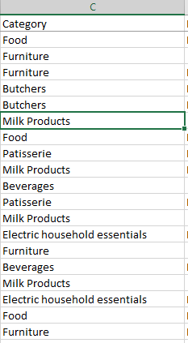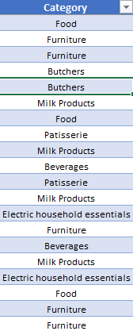
2.Remove the Duplicates: After completing this process I started to clean and removed the data in duplicate column.

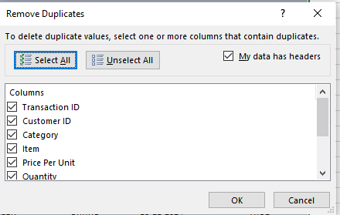

3.Missing Values in Item: I noticed missing values in the item sequence, but I did not consider them duplicates and filled them sequentially. For instance, if the unit price is 5, the corresponding item number is 1.
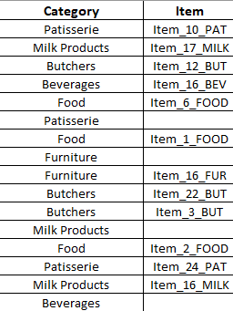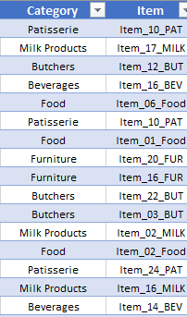

4.Missing value in price per unit column: For the missing values of price per unit column were calculated using the formula.
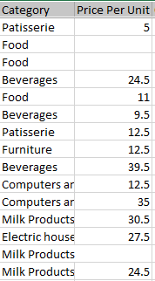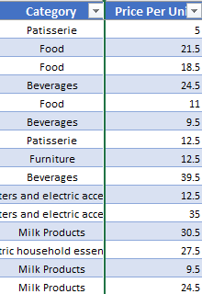

5.Missing value in Quantity column: For the missing values of quantity column were calculated using Item mode values.
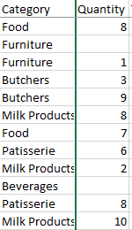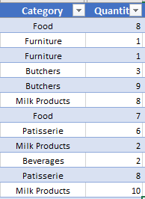

6. Missing value in Total Spent column: For the missing values of quantity column were calculated using Item mode values.
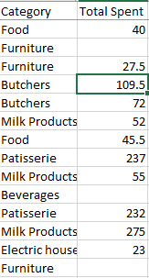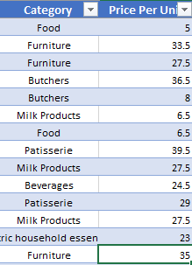

7. Find the Total Sales value in DAX using Power BI

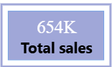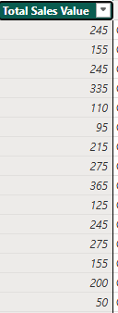
8. Find the Total Product Count value in DAX using Power BI
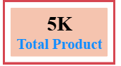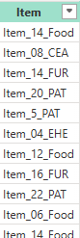
8. Find the Total Average sales value in DAX using Power BI

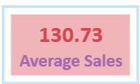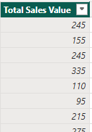

9. Find the Total count of Quantity value in DAX using Power BI
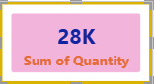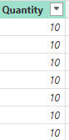
10. Bar Chart: The bar chart compares total sales across different product categories. It shows that Butchers has the highest sales, followed by Furniture and Food, while Milk Products has the lowest sales. This indicates which categories contribute most to revenue and which need improvement.
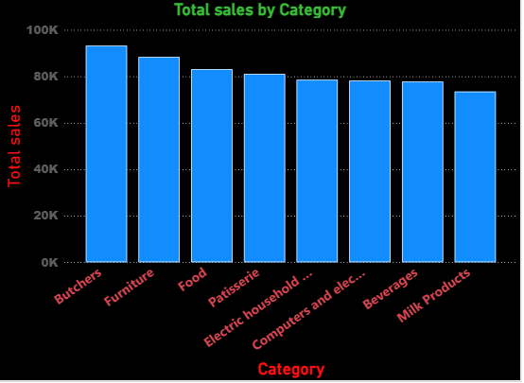

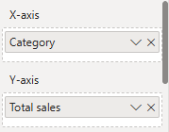
Key Insights
- Butchers’ category generates the highest revenue.
- Furniture and Food are strong contributors.
- Milk Products show the lowest sales, indicating improvement opportunity.
- Business should prioritize top-selling categories for stock and promotions.
11. Donut Chart: The donut chart displays the percentage distribution of sales by payment method. It shows that Cash, Credit Card, and Digital Wallet are almost equally used, with a slight preference for Cash and Digital Wallets. This indicates balanced customer payment behaviour with growing digital adoption.

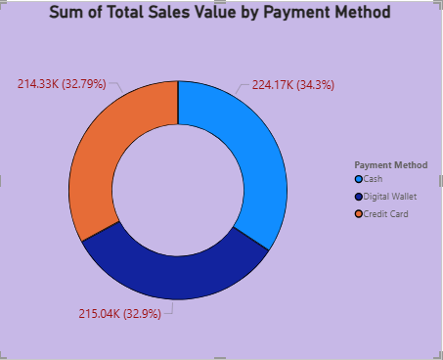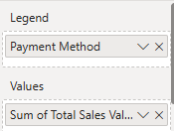

Key Insights:
- Cash, Credit Card, and Digital Wallet usage is almost evenly split.
- Slight dominance of Digital Wallet & Cash, showing digital adoption.
- Retailer must support multiple payment options to satisfy customer.

12. Monthly Sales Trend (Line Chart): To analyze sales performance over time and identify trends or seasonality.

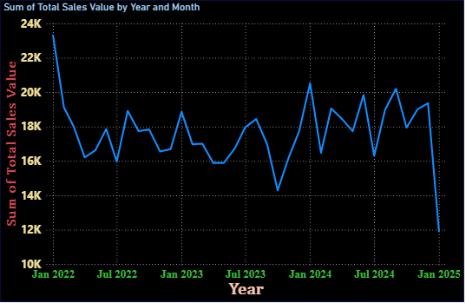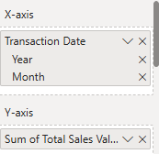
Key Insights:
- Sales show fluctuations month by month, not a constant pattern.
- There is a peak around early 2024, indicating higher customer activity.
- A drop towards the latest months suggests seasonal effects or reduced demand.
- Useful for forecasting and planning inventory.
13.Tree Map: To analyze Category performance Total sales value and sum of price per unit identify the trends.
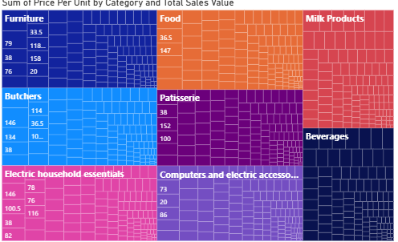
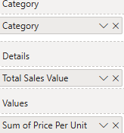
- Food and Milk Products dominate overall sales value, indicating they are the primary revenue drivers despite moderate unit prices.
- Beverages occupy a large area with relatively balanced pricing, showing consistent demand and stable contribution to total sales.
- Furniture and Computers & Electric Accessories show higher price per unit but smaller sales value, suggesting they are high-ticket but lower-volume categories.
- Butchers and Patisserie contribute mid-level sales, reflecting steady but not peak demand, likely dependent on daily/seasonal consumption.
- Electric household essentials have moderate pricing with decent sales share, indicating essential-use products with repeat purchases.
- Summary:
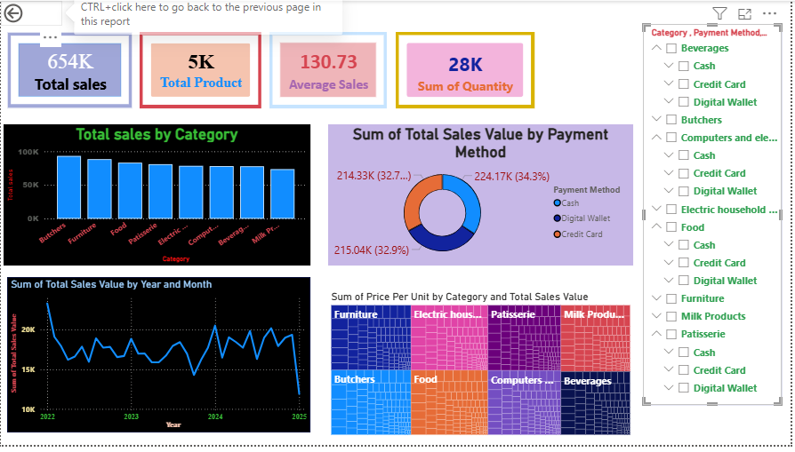
The dashboard shows 654K total sales with balanced performance across categories and payment methods. Sales fluctuate over time, and slicers enable quick, interactive analysis by category and payment type.

